SIMATS ENGINEERING
ASSESSMENT TOOL 2

NAME: Samuel V REG.NO: 192412237

COURSE NAME: COMPUTER NETWORKS

COURSE CODE: CSA0714

COURSE OUTCOME COVERED

CO4:
Design network topologies star, mesh, bus, and hybrid using networking devices, transmission media, and cabling standards
(BL2,BL6)

Assessment Tool Weightage: 30%

Annexure A

Industry Problem-Solving Task

1. A large university campus serves thousands of users across multiple buildings — lecture halls, labs, libraries, dormitories, and administration — making a single topology inadequate. A hybrid topology combines the best elements of multiple designs: a fiber based ring or mesh at the campus backbone level for redundancy, a star topology within each building for manageability, and bus or tree structures within individual labs for cost-efficiency. At the campus core, high-speed fiber optic cables (single-mode, 10 Gbps or 40 Gbps) interconnect core routers and multilayer switches using a ring or partial mesh arrangement, ensuring that no single link failure isolates an entire building. Each building has its own distribution switch connected to the campus core via dual fiber uplinks. Within each building, a traditional star topology branches from the distribution switch to floor-level access switches, which then connect individual devices via Cat6 cables. This hierarchical three-layer model — core, distribution, and access — is the industry standard for enterprise and campus networks because adding a new building simply means installing a new distribution switch and running fiber to the core, with no disruption to existing infrastructure. Wireless access points throughout the campus connect via PoE (Power over Ethernet) to access switches, eliminating the need for separate power cabling. The hybrid design thus delivers redundancy at the backbone, simplicity at the building level, and scalability campus-wide.

Aim
To study the star, mesh, bus, and hybrid network topologies, and to design a hybrid campus network topology that integrates these basic topologies at the backbone, building, and lab levels using appropriate networking devices, transmission media, and cabling standards.

Requirements
- Networking devices: core routers, multilayer switches, distribution switches, access switches, Power over Ethernet (PoE) enabled switches, wireless access points
- Transmission media: single-mode fiber optic cable (10 Gbps / 40 Gbps), Cat6 twisted-pair cabling
- Network design / simulation tool (e.g., Cisco Packet Tracer or equivalent) for drawing and verifying the topology

Theory
A network topology defines how devices and cables are physically or logically arranged to form a network. The four fundamental topologies and their characteristics are summarized below.
Topology | Structure | Advantages | Limitations
Star | All nodes connect individually to a central device (switch/hub) | Easy to manage, isolate faults, and add devices | Central device is a single point of failure
Mesh | Each node connects directly to every other node (full) or to several nodes (partial) | High redundancy and fault tolerance; no single link failure isolates the network | Expensive cabling and complex wiring, especially at large scale
Bus | All devices share a single backbone cable with terminators at each end | Low cost, minimal cabling, simple to set up for small segments | Backbone failure disables the whole segment; limited scalability
Hybrid | Combination of two or more topologies (e.g., ring/mesh backbone + star buildings + bus labs) | Combines redundancy, manageability, and cost-efficiency of the constituent topologies | More complex to design, configure, and troubleshoot

Problem Statement
A large university campus serves thousands of users across multiple buildings — lecture halls, labs, libraries, dormitories, and administration — making a single topology inadequate. A hybrid topology combines the best elements of multiple designs: a fiber-based ring or mesh at the campus backbone level for redundancy, a star topology within each building for manageability, and bus or tree structures within individual labs for cost-efficiency.
At the campus core, high-speed fiber optic cables (single-mode, 10 Gbps or 40 Gbps) interconnect core routers and multilayer switches using a ring or partial mesh arrangement, ensuring that no single link failure isolates an entire building. Each building has its own distribution switch connected to the campus core via dual fiber uplinks. Within each building, a traditional star topology branches from the distribution switch to floor-level access switches, which then connect individual devices via Cat6 cables.
This hierarchical three-layer model — core, distribution, and access — is the industry standard for enterprise and campus networks because adding a new building simply means installing a new distribution switch and running fiber to the core, with no disruption to existing infrastructure. Wireless access points throughout the campus connect via PoE (Power over Ethernet) to access switches, eliminating the need for separate power cabling. The hybrid design thus delivers redundancy at the backbone, simplicity at the building level, and scalability campus-wide.

Implementation in VS Code
A lightweight Flask + HTML/CSS simulator was built to visualize the hierarchical hybrid topology and to test how the design behaves when a backbone link fails.

APP.PY
from flask import Flask, render_template, jsonify
app = Flask(__name__)
buildings = {
"Building A": {"role": "Lecture Halls", "core_node": "Core Router 1",
"uplinks": ["Primary", "Backup"], "access": "Star (Cat6)"},
"Building B": {"role": "Library", "core_node": "Core Switch 2",
"uplinks": ["Primary", "Backup"], "access": "Star (Cat6)"},
"Building C": {"role": "Dormitory", "core_node": "Core Switch 3",
"uplinks": ["Primary", "Backup"], "access": "Star + PoE AP"},
"Building D": {"role": "Labs", "core_node": "Core Router 4",
"uplinks": ["Primary", "Backup"], "access": "Bus (cost-efficient)"},
}
@app.route("/")
def home():
return render_template("index.html", buildings=buildings)
@app.route("/network-status")
def network_status():
return jsonify({
"core": "Fiber ring active (10/40 Gbps)",
"distribution": "All dual uplinks healthy",
"access": "Star + Bus segments online"
})
@app.route("/simulate-failure/<building>")
def simulate_failure(building):
if building not in buildings:
return jsonify({"success": False, "message": "Invalid building"})
return jsonify({
"success": True,
"message": (
f"{building}: Primary fiber uplink DOWN -> "
"Backup uplink active -> Core ring re-routes traffic -> "
"No isolation, campus stays connected."
)
})
if __name__ == "__main__":
app.run(debug=True)

INDEX.HTML (excerpt)
<h1>Campus Hybrid Network Simulator</h1>
<div class="core">CORE RING — Single-mode Fiber, 10/40 Gbps</div>
{% for name, b in buildings.items() %}
<div class="building">
<h2>{{ name }}</h2>
<div class="switch">Distribution Switch → {{ b.core_node }}</div>
<p>Uplinks: {{ b.uplinks | join(', ') }}</p>
<p>Access layer: {{ b.access }}</p>
</div>
{% endfor %}
<button onclick="simulateFailure()">Simulate Primary Uplink Failure</button>

Output
The screenshots below show the rendered simulator: the hierarchical core-distribution-access topology, and the dashboard used to test a backbone link failure between buildings.
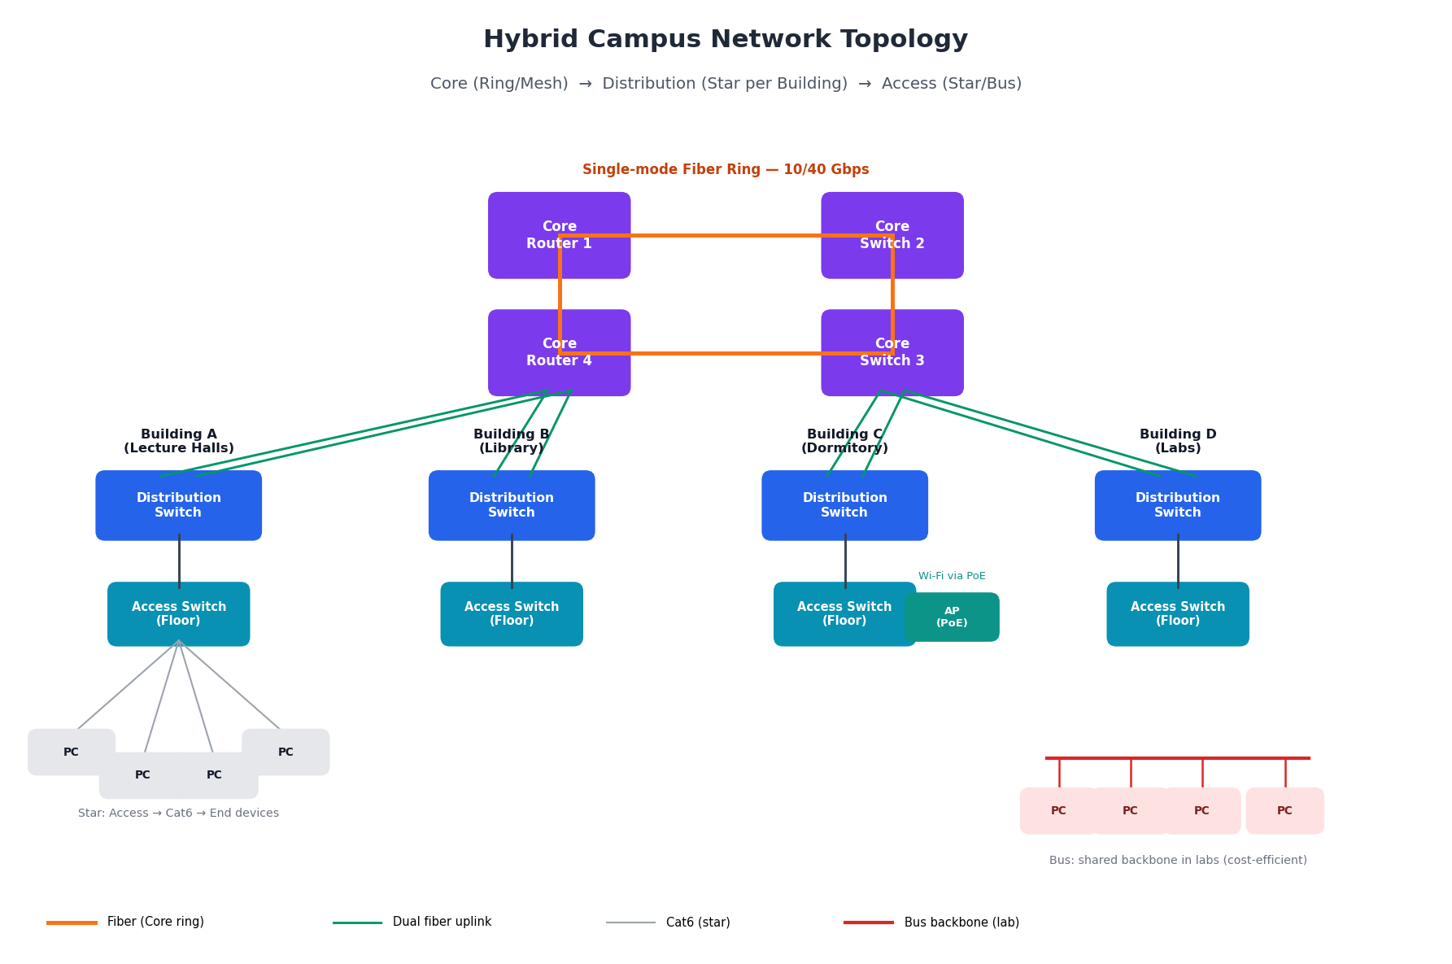
Fig 1: Hybrid campus topology — fiber core ring, distribution per building, star/bus access layer
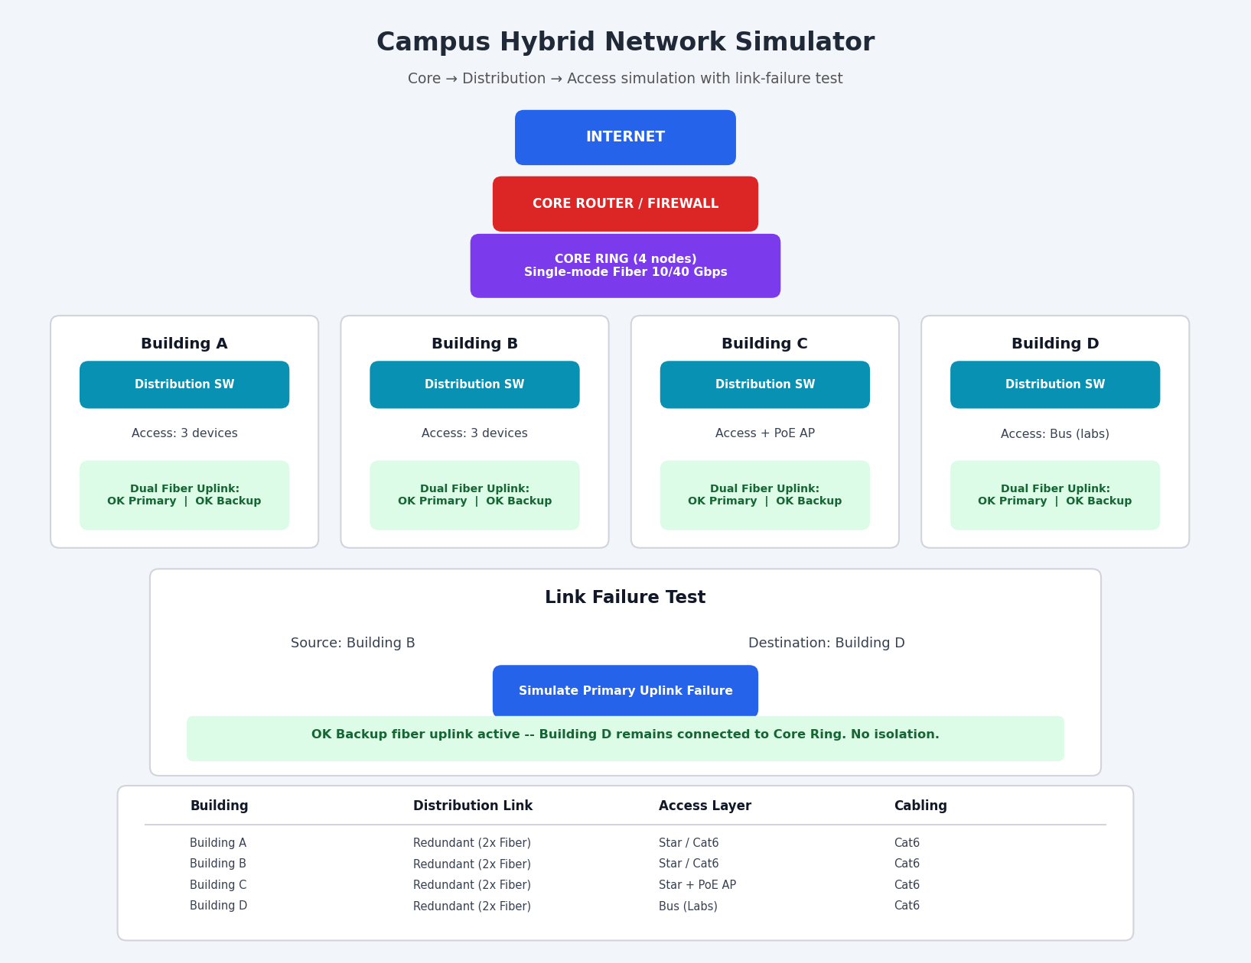
Fig 2: Simulator dashboard — building status and link-failure test output

How the Project Works
The implementation represents a 3-layer hierarchical hybrid network: the core layer (fiber ring/mesh) provides backbone redundancy, the distribution layer gives each building its own switch on a dual-fiber uplink, and the access layer connects end devices using a star (offices, dorms) or bus (labs) arrangement depending on cost and density needs.

Link Configuration
The design below adapts the department/VLAN pattern of the reference task to a campus-wide hybrid topology: instead of one router serving flat departments, each building gets its own distribution switch on a redundant fiber pair back to a fault-tolerant core ring.
Building | Distribution Link | Access Layer | Cabling
Building A | Redundant (2x Fiber) | Star / Cat6 | Cat6
Building B | Redundant (2x Fiber) | Star / Cat6 | Cat6
Building C | Redundant (2x Fiber) | Star + PoE AP | Cat6
Building D | Redundant (2x Fiber) | Bus (Labs) | Cat6

What Happens During the Link-Failure Test
For example, testing Building B → Building D with the primary uplink of Building D simulated as down:
- Building D Distribution Switch → Primary fiber uplink DOWN
- Backup fiber uplink activates automatically
- Core ring re-routes traffic through the alternate path
- Building D remains reachable — confirming no single link failure isolates a building
The application displays this outcome when “Simulate Primary Uplink Failure” is clicked, demonstrating the redundancy designed into the core and distribution layers.

What You Can Explain During Presentation
Problem: A university campus has many buildings and needs a scalable, fault-tolerant network.
Solution: A hybrid topology — ring/mesh at the core, star per building, bus within labs.
Core layer: Core routers/multilayer switches in a fiber ring or partial mesh (10/40 Gbps, single-mode).
Distribution layer: One distribution switch per building on a dual fiber uplink to the core.
Access layer: Floor-level access switches in a star to end devices via Cat6; bus/tree inside labs.
Wireless: PoE-enabled access switches power APs over the same Ethernet cable.
Redundancy: Ring/mesh core plus dual uplinks mean a single link failure never isolates a building.
Scalability: A new building only needs a distribution switch and a fiber run to the core.

Design Approach
The proposed design follows the hierarchical three-layer model — core, distribution, and access — which is the industry standard for enterprise and campus networks.
Core layer: A fiber-based ring or partial mesh topology interconnects the core routers and multilayer switches at the campus backbone. High-speed single-mode fiber optic links (10 Gbps or 40 Gbps) ensure that no single link failure isolates an entire building, providing redundancy at the heart of the network.
Distribution layer: Each building is equipped with its own distribution switch, connected to the campus core through dual fiber uplinks. This redundant connection protects each building from a single point of failure at the backbone-to-building link.
Access layer: Within each building, a traditional star topology branches from the distribution switch to floor-level access switches, which connect individual end devices using Cat6 cabling. Inside individual labs, bus or tree structures are used at the device level for cost-efficiency where large numbers of low-priority endpoints are connected.
Wireless access points deployed throughout the campus connect to access switches via Power over Ethernet (PoE), which supplies both data connectivity and electrical power over the same cable, eliminating the need for separate power cabling.

6. Devices, Media, and Cabling Standards Used
Campus Layer | Devices Used | Transmission Media / Cabling
Core (Backbone) | Core routers, multilayer (Layer 3) switches arranged in a ring or partial mesh | Single-mode fiber optic cable, 10 Gbps or 40 Gbps links
Distribution (Building) | Distribution switch per building with dual uplinks to the core | Fiber optic uplinks (redundant pair per building)
Access (Floor/Lab) | Floor-level access switches, PoE-enabled switches for wireless access points | Cat6 twisted-pair cabling to end devices; PoE eliminates separate power cabling for APs

7. Advantages of the Hybrid Design
- Redundancy at the backbone: ring/mesh core ensures no single link failure isolates a building
- Simplicity and manageability at the building level: star topology makes fault isolation and device addition straightforward
- Cost-efficiency within labs: bus/tree structures reduce cabling costs for dense endpoint clusters
- Scalability: adding a new building only requires a new distribution switch and a fiber run to the core, with no disruption to existing infrastructure
- Simplified power delivery: PoE removes the need for separate electrical wiring to wireless access points

8. Conclusion
The hybrid topology, structured on the core–distribution–access hierarchical model, successfully combines the redundancy of a mesh/ring backbone, the manageability of a star topology within buildings, and the cost-efficiency of bus/tree structures within labs. This design meets the scalability, reliability, and manageability requirements of a large university campus network, and adding new buildings or segments can be accomplished with minimal disruption to the existing infrastructure.

Rubrics for Evaluation
Criteria | Weightage | Exemplary (4) | Proficient (3) | Developing (2) | Beginning (1)
Problem Analysis | 15% | Clearly identifies and deeply analyzes the industry problem with all factors | Good understanding with minor gaps | Basic understanding; some key aspects missing | Poor or incorrect understanding of the problem
Solution Design | 20% | Innovative, practical, and industry-relevant solution | Effective solution with minor limitations | Partially suitable solution | Inappropriate or unclear solution
Technical Implementation | 20% | Fully functional, accurate, and well-executed implementation | Mostly functional with minor errors | Partially implemented solution | Incomplete or non-functional implementation
Use of Tools & Technologies | 10% | Appropriate and advanced use of relevant tools and technologies | Correct use of tools | Limited or basic use of tools | Incorrect or no use of tools
Problem-Solving Approach | 10% | Logical, systematic, and well-structured approach | Mostly logical approach | Somewhat disorganized approach | No clear approach
Innovation & Creativity | 10% | Highly creative and original solution | Some creativity | Limited originality | No creativity
Testing & Validation | 5% | Thorough testing with real-world scenarios | Adequate testing | Minimal testing | No testing
Documentation & Presentation | 5% | Clear, professional, and well-documented | Good documentation | Basic documentation | Poor or no documentation
Teamwork / Collaboration | 5% | Excellent coordination and contribution (if team-based) | Good collaboration | Limited participation | No collaboration or contribution

